Dashboard Analysis
Team ID | MCA
Project Name | Smartphone Usage, Digital Addiction & Well-Being Analytics
Maximum Marks | 5 Marks

Dashboard Overview and Design Approach
The main objective of this dashboard is to study daily digital habits, screen exposure, and lifestyle health across different user segments. By combining clean chart designs with straightforward filters, the interface allows evaluators and observers to quickly understand the connection between high screen time and personal well-being.
Key Design Focus Areas:
- Simple Layout Flow: Organized cards at the top for primary metrics and structured charts below for demographic comparisons.
- Balanced Visual Formats: Horizontal bar charts for category comparisons and pie charts for distribution breakdowns.
- Colour Discipline: Distinct, clean tones to clearly mark severity and categories without cluttering the view.
- Quick Slicing: Dedicated filters to check metrics by specific addiction ranges or user demographics.

Digital Well-Being & Addiction Insights Dashboard
The main use of this dashboard is to easily track how excessive phone usage affects daily routine, sleep patterns, and stress levels among users. It helps to quickly spot high-risk groups—especially college students and young working people—who spend too much time on mobile screens during weekends. Faculty members, counsellors, and health advisors can use these visual insights to organize digital detox awareness sessions, guide students on healthy phone habits, and plan timely lifestyle guidance.
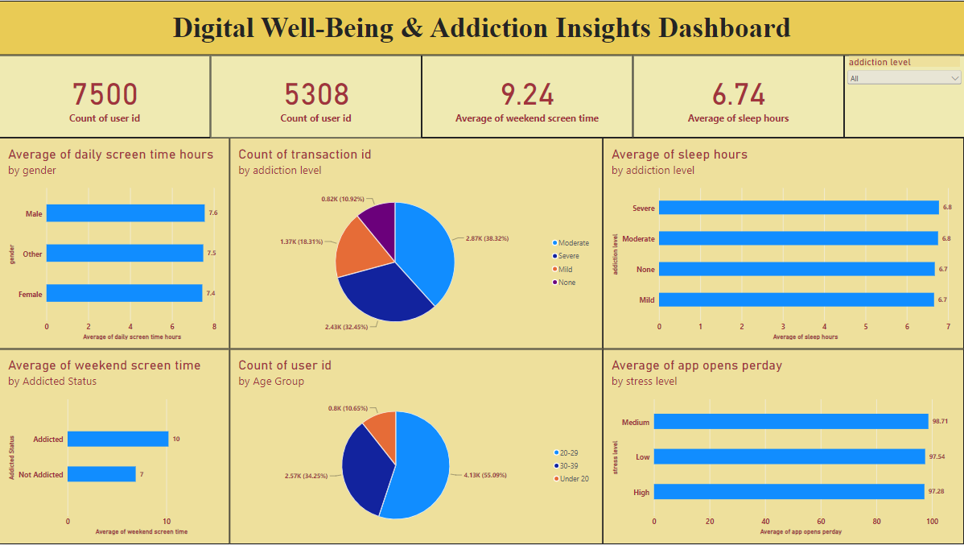
Here are eight potential outcomes from the dashboard image provided:
- Total User Base: A total of 7,500 individuals were assessed across all age groups and usage categories.
- Prevalence of Addiction: Out of the entire cohort, 5,308 users demonstrate clear patterns of smartphone dependency.
- Weekend Device Engagement: On weekends, users spend an average of 9.24 hours actively using their devices.
- Overall Sleep Average: Across all respondent categories, participants log an average sleep cycle of 6.74 hours per day.
- Consistent Usage Across Genders: Daily device use remains practically identical across gender categories, standing at 7.6 hours for males, 7.4 hours for females, and 7.5 hours for other gender identities.
- Severity Distribution: About 38.32% (2,870 users) have moderate addiction, 32.45% (2,430 users) suffer from severe addiction, 18.31% (1,370 users) report mild dependency, and only 10.92% (820 users) show no addiction signs.
- Weekend Difference: Users flagged with digital addiction spend 10 hours on weekend screens, compared to 7 hours recorded by non-addicted users.
- Major Age Participation: Young adults aged 20 to 29 form the largest share of the study at 55.09% (4,130 users), followed by the 30–39 group at 34.25% (2,570 users), and those under 20 at 10.65% (800 users).

